**PROJECT REPORT**

# ON

**“*LOAN APPROVAL PREDICTION”***

The project submitted to Smart Internz

By

DANDU VINODKUMAR

CHALLA LAHARI

KANISETTY SRINIVAS

POTTIPATI KAVYAKALYANI

CHIKKANI CHANDU

## SRI VENKATESWARA COLLEGE OF ENGINEERING

**(Approved by AICTE & Affiliated to JNTUA)**

**Balaji Nagar, Kadapa-516003**

**DEPARTMENT OF CSE (ARTIFICIAL INTELLIGENCE &**

**MACHINE LEARNING)**

**Under the Supervision of:** **Submitted By:**

G. Pradeep Kumar, M. Tech D. Vinod Kumar(2OKH1A3312)

Assistant Professor

**CERTIFICATE**

This is to certify Mr **D. Vinod Kumar(20KH1A3312)** Studying in Sri Venkateswara College of Engineering, Kadapa (Batch: 2020-2024) have completed the project entitled “**Loan Approval Prediction” at** Sri Venkateswara College of Engineering Under my supervision. It is further certified that he had attended required number of practical classes at Sri Venkateswara College of Engineering for the completion of their project During 6 Semester.

D. vinod kumar

(20KH1A3312)

**G. Pradeep Kumar**

**Assistant Professor**

## ACKNOWLEDGEMENT

Engineers in all disciplines must acquire knowledge of project making. Student, in particular, will find “project making” as an integral part of their studies that will infuse the spirit of doing practical work in them

The satisfaction that accompanies the successful completion of any task would be incomplete without the mention of the people who made it possible whose constant guidance crowned our efforts with success.

We sincerely express our deep gratitude to the management of our college for giving the liberty to choose and to work on the most relevant project i.e., **“Personal Loan Approval Prediction”.** We are thankful to **Mr. P.A. Ramesh,** **HOD of CSE (AI & ML)**, for ensuring that we have a smooth environment at the college and lab. At the very outset we would like to offer our never ending thanks to our project supervisor **G. Pradeep Kumar, M. Tech** (Assistant Professor) who helped us with our project from the beginning till the end. Her continuous surveillance over our work allowed us to work more efficiently.

D. vinod Kumar

(20KH1A3312)

## ABSTRACT

In India, the number of people or organization applying for loan gets increased every year. The bank employees have to put in a lot of work to analyse or predict whether the customer can pay back the loan amount or not (defaulter or non-defaulter) in the given time.

Banking Industry always needs a more accurate predictive modelling system for many issues. Predicting credit defaulters is a difficult task for the banking industry. The loan status is one of the quality indicators of the loan. It doesn't show everything immediately, but it is a first step of the loan lending process.

### CONTENTS

|  |  |  |
| --- | --- | --- |
| **Sl. No** | **CONTENTS** | **Page No** |
| 1 | INTRODUCTION  1.1 Overview  1.2 Purpose | 1 |
| 2 | LITERATURE SURVEY  2.1 Existing problems | 2-3 |
| 3 | THEORETICAL ANALYSIS  3.1 Group Ideas  3.2 Prioritize | 3 |
| 4 | RESULT | 4 |
| 5 | ADVANTAGES & DISADVANTAGES | 4-5 |
| 6 | APPLICATIONS | 5 |
| 7 | CONCLUSION | 6 |
| 8 | FUTURE SCOPE | 7 |

## 1.INTRODUCTION

1.1 Overview

A loan is a sum of money that is borrowed and repaid over a period of time, typically with interest. There are various types of loans available to individuals and businesses, such as personal loans, mortgages, auto loans, student loans, business loans and many more. They are offered by banks, credit unions, and other financial institutions, and the terms of the loan, such as interest rate, repayment period, and fees, vary depending on the lender and the type of loan.

A personal loan is a type of unsecured loan that can be used for a variety of expenses such as home repairs, medical expenses, debt consolidation, and more. The loan amount, interest rate, and repayment period vary depending on the lender and the borrower's credit worthiness. To qualify for a trained on historical data of loan applications, where each application would be associated with a set of features such as the borrower's credit score, income, employment history, debt-to- income ratio, loan amount, and other relevant factors.

The aim of this project would be to build a predictive model that can accurately classify loan applications as either approved or rejected. The model could be used by lenders to make informed decisions about which loan applications to approve and which to reject, based on the likelihood of the borrower repaying the loan. To develop this model, a machine learning approach would be used, where a dataset of historical loan applications would be split into a training set and a testing set. The training set would be used to train the model on the different feature and their impact on loan approval, while the testing set would be used to evaluate the model's performance and accuracy.

Some of the techniques that could be used to build this model include logistic regression, decision trees, random forests, or gradient boosting. Additionally, the model's performance could be improved by using techniques such as feature engineering, hyperparameter tuning, and cross-validation.

### 1.2 Purpose

The purpose of a personal loan approval project would be to develop a model that can predict whether an individual will be approved for a personal loan or not. This model would be

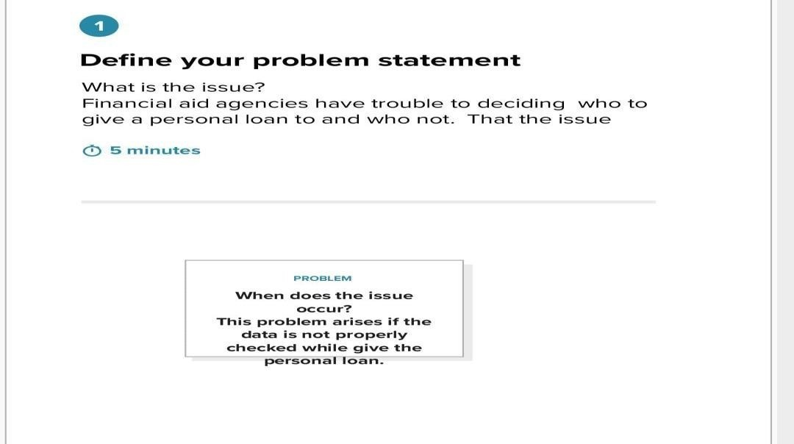2.

**2.LITERATURE SURVEY**

### 2.1 Existing Problem

The problem of predicting personal loan approval involves using data analysis and machine learning algorithms to predict whether a borrower will be approved for a personal loan or not. This problem is important for both lenders and borrowers. Lenders need to accurately assess the risk of lending money to borrowers, while borrowers need to understand their chances of getting approved and prepare accordingly. The problem of predicting personal loan approval involves analysing various factors such as the borrower's credit history, income, employment status, debt-to-income ratio, loan amount, and loan purpose, among others. Machine learning algorithms such as logistic regression, decision trees, and neural networks can be used to analyse these factors and predict whether a borrower will be approved or not. The accuracy of the prediction model depends on the quality and quantity of data used for training and testing the model. Therefore, it is important to have a large and diverse dataset to ensure that the model is robust and can generalize well to new data. Additionally, feature engineering, data preprocessing, and model selection are important steps in building an

accurate prediction model. Overall, the problem of predicting personal loan approval is an important and challenging task that requires careful analysis and modelling to ensure accurate predictions

## 3. THEORETICAL ANALYSIS

**3.1Block Diagram**

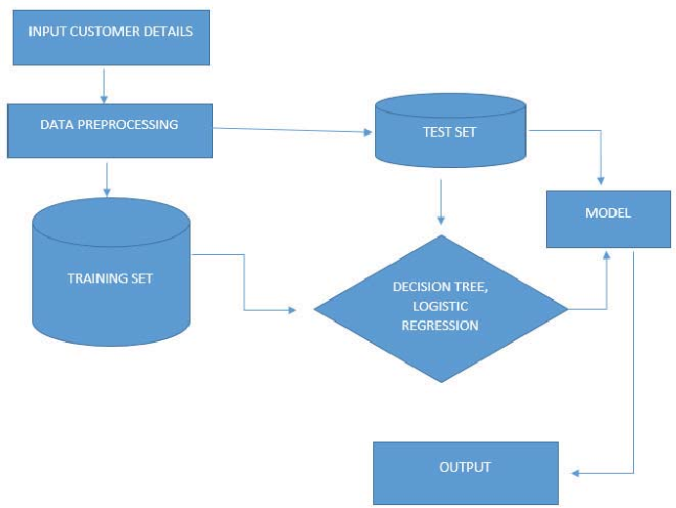

**3.2Group Ideas**

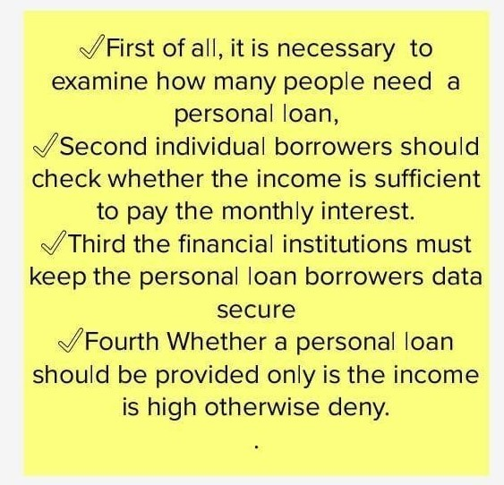

**3.3 prioritize**

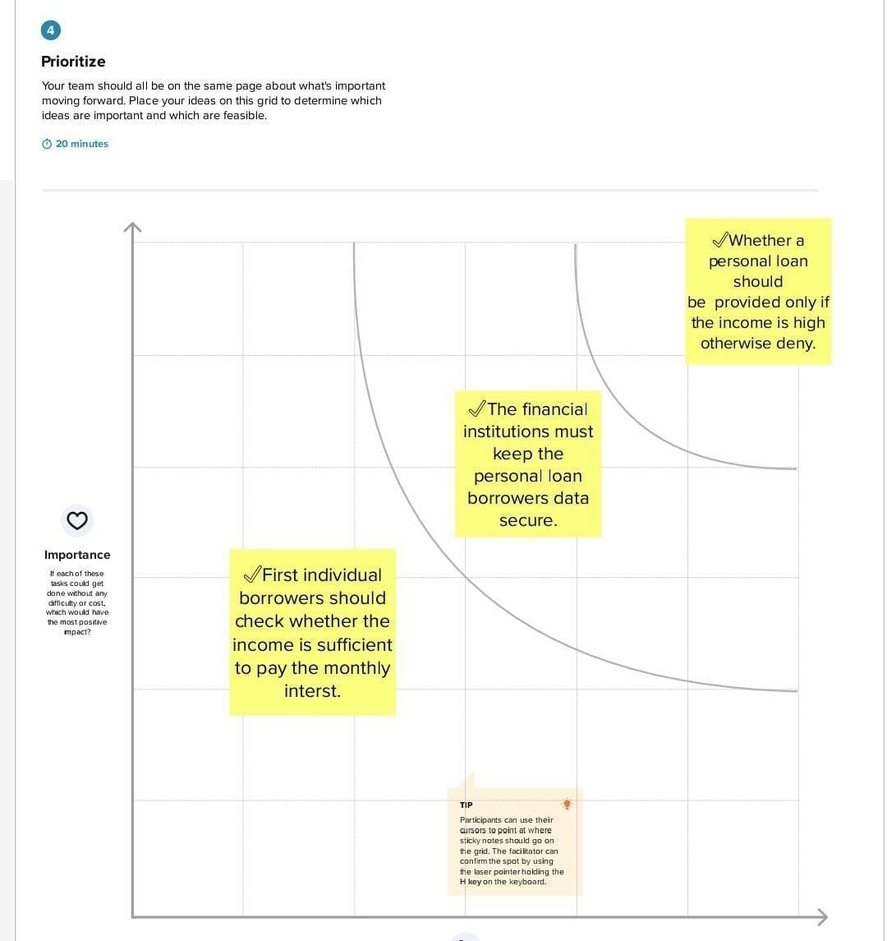

## 4.RESULT

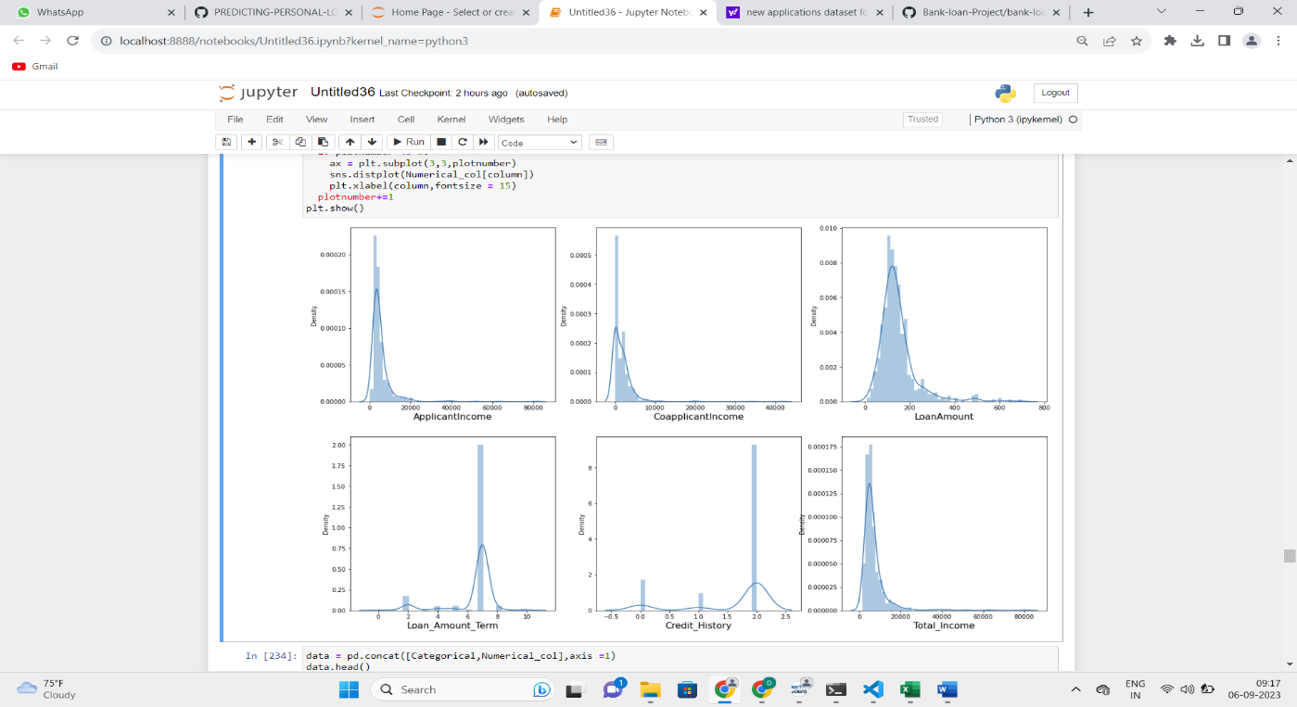

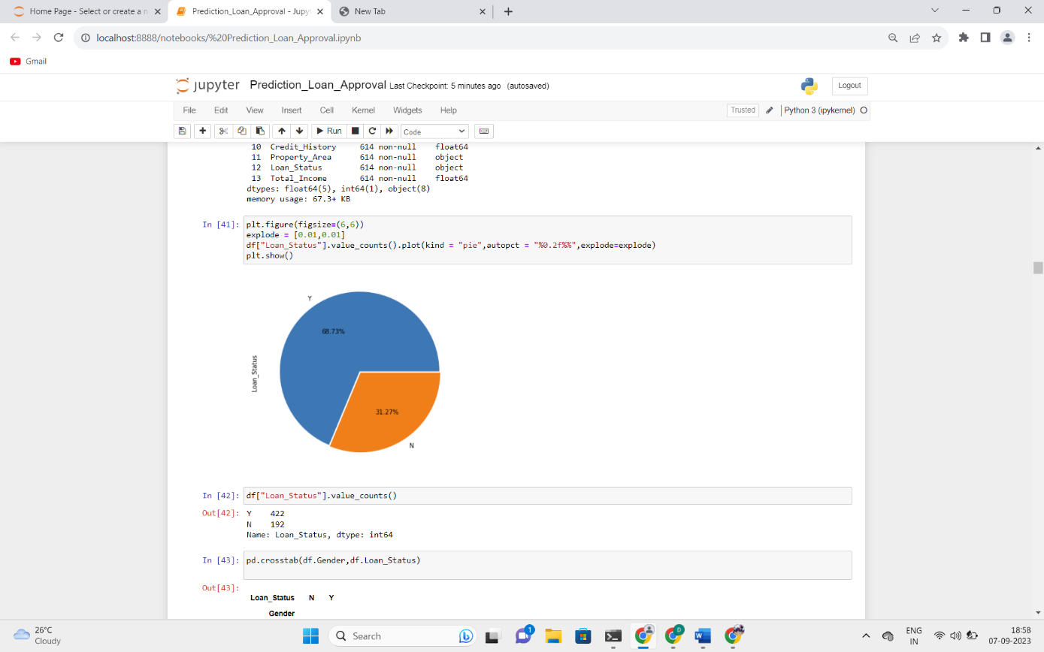

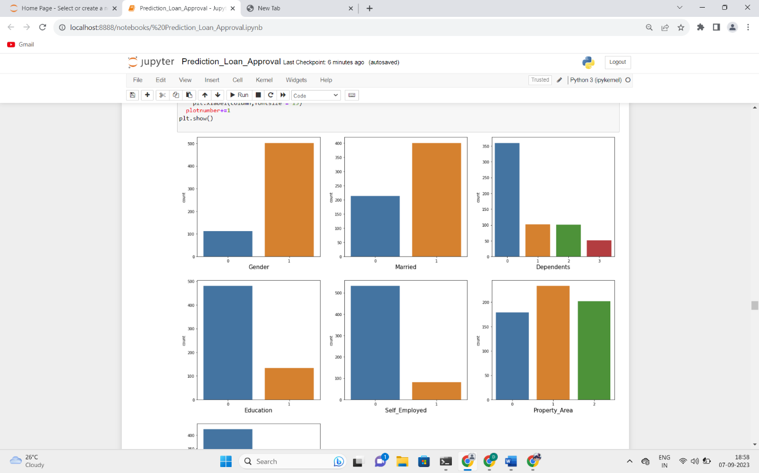

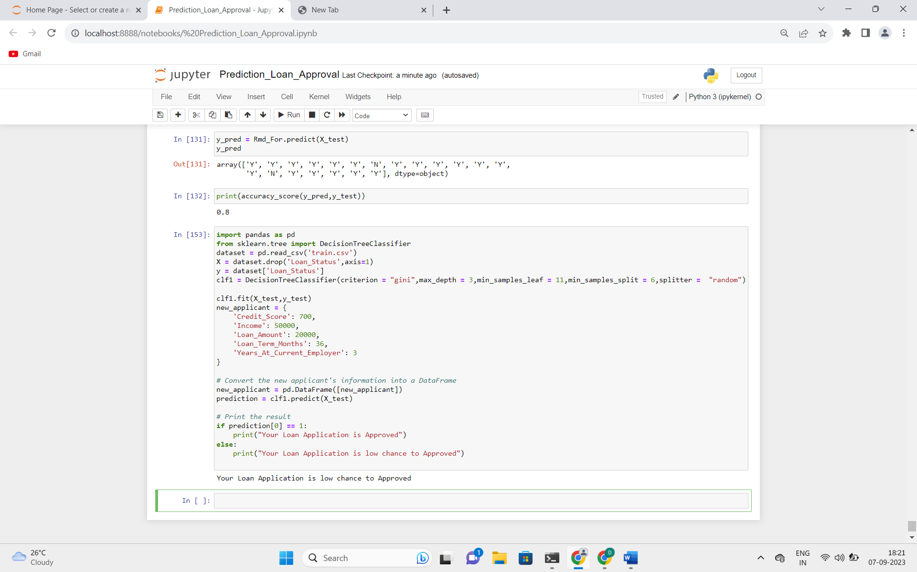

## 5.ADVANTAGES & DISADVANTAGES

### 5.1 Advantages

* Increased Efficiency: Machine learning algorithms can analyse large amounts of data quickly and accurately, allowing lenders to process loan applications faster and more efficiently. This can result in reduced manual effort, streamlined workflows, and

quicker decision-making, saving both time and resources.

* Enhanced Accuracy: Machine learning models can analyse various data points,

including credit scores, income levels, employment history, and other relevant factors, to predict the likelihood of loan approval with high accuracy. This can reduce the risk of human errors and bias in decision-making, resulting in more consistent and reliable

loan approval predictions.

* Improved Risk Assessment: Machine learning algorithms can assess the creditworthiness of borrowers more accurately by analysing historical data on loan defaults and other risk factors. This helps lenders make informed decisions about loan

approvals, minimizing the risk of default and potential financial losses.

* Personalized Loan Offers: Machine learning models can analyse individual borrower profiles and generate personalized loan offers based on their financial situation, credit history, and other relevant factors. This can result in more customized loan terms and

interest rates, increasing the chances of loan approval and borrower satisfaction.

### 5.2 Disadvantages

* Bias and Fairness Concerns: Machine learning models can inadvertently incorporate bias from historical data, resulting in biased loan approval decisions. This can perpetuate discriminatory lending practices, such as racial or gender bias, and result in

unfair treatment of certain groups of borrowers.

* Lack of Interpretability: Some machine learning models, such as deep learning algorithms, may lack interpretability, making it challenging to understand how the model arrives at its predictions. This can make it difficult for lenders to explain loan

approval decisions to borrowers or regulators, which may raise concerns about

transparency and accountability.

* Overreliance on Data: Machine learning models rely heavily on data for training and prediction, and if the data used is incomplete, inaccurate, or biased, it can negatively impact the model's performance and the loan approval decisions. Ensuring high-quality,

representative, and unbiased data can be a challenge.

* Changing Regulatory Landscape: Regulations governing lending practices and data privacy can evolve, and complying with these regulations can be complex. Machine learning models used for loan approval may need to be updated or modified to ensure compliance with changing regulatory requirements, which can be time-consuming and resource-intensive.

## 6.APPLICATIONS

Predicting personal loan approval using machine learning has a wide range of applications

across the financial industry, including:

1. Banks and financial institutions: Banks and other financial institutions can use machine learning to automate the loan approval process and make more accurate loan approval

decisions. This can lead to faster loan processing times, reduced costs, and improved customer

satisfaction.

1. Peer-to-peer lending platforms: Peer-to-peer lending platforms can use machine learning to evaluate borrower creditworthiness and make loan approval decisions. This can help ensure that loans are being made to creditworthy borrowers and reduce the risk of default.
2. Credit scoring companies: Credit scoring companies can use machine learning to develop more accurate credit scoring models, which can be used by lenders to make loan approval decisions. This can help improve access to credit for underserved populations and reduce the

risk of default.

1. Insurance companies: Insurance companies can use machine learning to assess the risk of lending to borrowers and make more accurate loan approval decisions. This can help reduce the risk of default and improve the profitability of insurance products.
2. Fintech startups: Fintech startups can use machine learning to develop innovative loan approval products and services, such as microloans and instant loan approvals. This can help improve access to credit for underserved populations and reduce the risk of default.

## 7.CONCLUSION

Random Forest Classifier is giving the best accuracy with an accuracy score of 82% for the testing dataset. And to get much better results ensemble Learning techniques like Bagging and Boosting can also be used. Predicting personal loan approval using machine learning can be an effective tool for lenders to make informed decisions about loan applications. By analysing various factors such as credit score, income, employment status, and loan history, machine learning algorithms can accurately predict whether an applicant is likely to be approved for a personal loan or not. Through the use of supervised learning algorithms such as logistic regression, decision trees, and neural networks, lenders can train their models on historical data to make accurate predictions about future loan applicants. These algorithms can help lenders identify risky loan applicants and reduce the risk of default. In conclusion, machine learning can be a powerful tool for predicting personal loan approval. Lenders can use machine learning algorithms to analyse a large amount of data and make informed decisions about loan approvals. However, it's important to ensure that the algorithms are trained on unbiased data and that ethical considerations are taken into account to avoid discrimination and maintain fairness in lending practices.

## 8.FUTURE SCOPE

The future scope of predicting personal loan approval using machine learning is very promising. As the financial industry continues to become more data-driven, machine learning models are expected to play an increasingly important role in the loan approval process. Here are some potential future developments:

1.Use of more advanced machine learning techniques: As machine learning techniques continue to evolve, more advanced algorithms and models may be developed that can improve loan approval predictions even further. For example, deep learning techniques may be used to analyse unstructured data, such as borrower social media activity, to improve loan approval predictions.

2.Integration with blockchain technology: Blockchain technology has the potential to improve the security and transparency of the loan approval process, and may be integrated with machine learning models to further improve loan approval predictions.

3.Collaboration between lenders: Lenders may collaborate to share data and develop more accurate loan approval models. This could lead to more consistent loan approval decisions across different lenders, and could help reduce the risk of default.

4.Increased use of alternative data sources: Machine learning models may be trained on alternative data sources, such as mobile phone usage data or utility bill payment history, to improve loan approval predictions. This could help improve access to credit for underserved populations who may not have traditional credit histories.

5.Expansion to other types of loans: The use of machine learning to predict loan approvals may expand to other types of loans, such as business loans, mortgage loans, and car loans.

Overall, the future scope of predicting personal loan approval using machine learning is very promising, and is likely to lead to continued improvements in the speed, efficiency, and accuracy of the loan approval process.